**Lab – 46: How to configure device restriction settings in Microsoft Intune?**

**Objective:** The objective of this lab is –

* To configure device restriction settings in Microsoft Intune.

Device restrictions let you control a wide range of settings and features you manage across a range of categories including security, browser, hardware, and data sharing settings. For example, you could create a device restriction profile that prevents users of Windows 10 devices from accessing screen capture, copy and paste, Camera and Internet Sharing.

**Prerequisite:** EMS Enterprise Mobility + Security E5.

**Steps:**

1. Sign in to your Azure Portal, by using the link - **https://portal.azure.com/**. Enter your credentials and click Sign In.

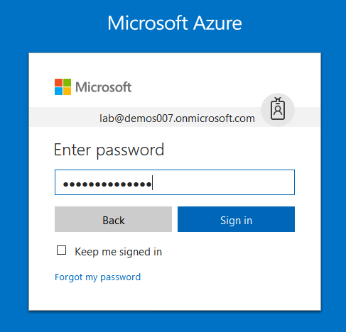

1. Microsoft Azure AD Dashboard will open.

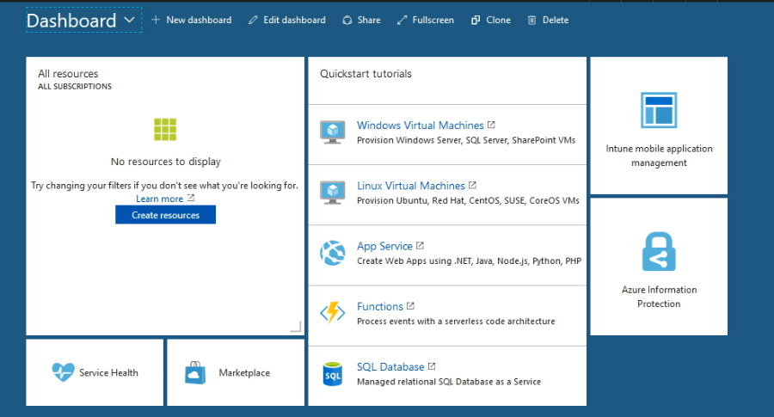

1. Open **Microsoft Intune** service from the left-hand side of the Azure portal.
2. Once you've opened the **Microsoft Intune** blade, select **Device Configuration**.

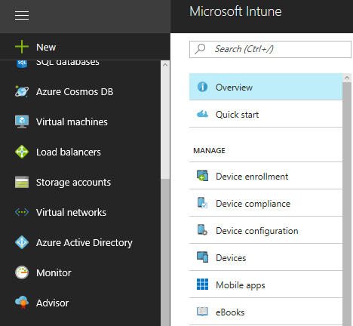

1. On the **Device Configuration** blade, choose **Manage** > **Profiles**.

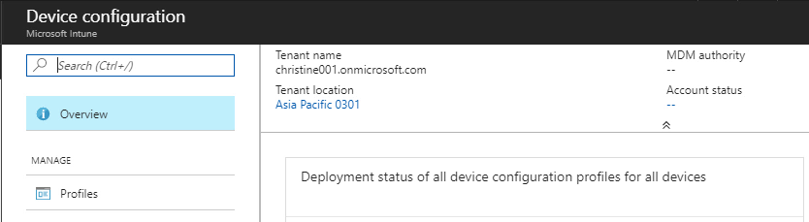

1. On the blade showing the list of profiles, choose **Create Profile**.

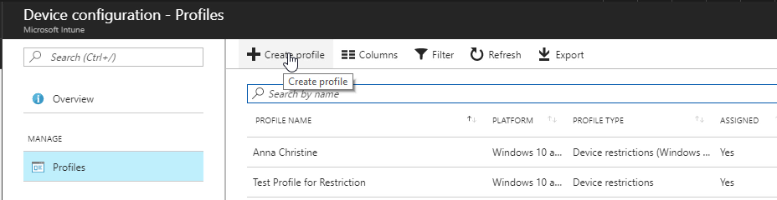

1. On the **Create Profile** blade, specify the items:

Name - Enter a descriptive name for the new profile.

Description - Enter an optional description for the profile.

Platform - Select the platform type for the profile you want to create. Here, select **Windows 10 and later**.

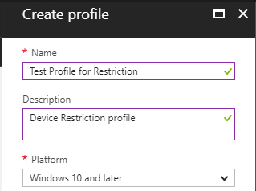

Profile type - Select the type of profile you want to create. Here, we are going to restrict the accessing so, that’s why select **Device restrictions** settings. If you want to create a device restrictions profile for Windows 10 Team devices like a Surface Hub, choose **Device restrictions (Windows 10 Team)**.

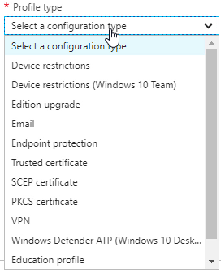

1. Then configure the settings and restrict the accessing of screen capture, copy and paste, Camera and Internet Sharing.

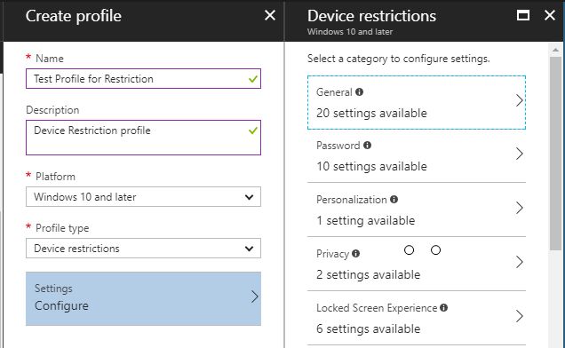

1. For this, select a category **General** and block the accessing of screen capture (mobile only), copy and paste (mobile only), Camera and Internet Sharing by selecting **Block** for their respective feature.

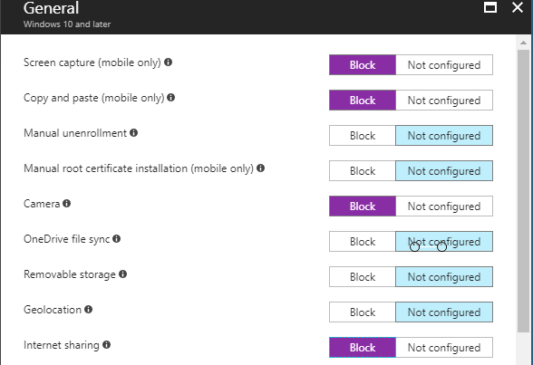

1. After configuring, click **OK**.
2. Then click **OK**, on device restrictions blade.
3. Once you are done configuring settings, on the **Create Profile** blade, choose **Create**.
4. The profile is created and appears on the profiles list blade.

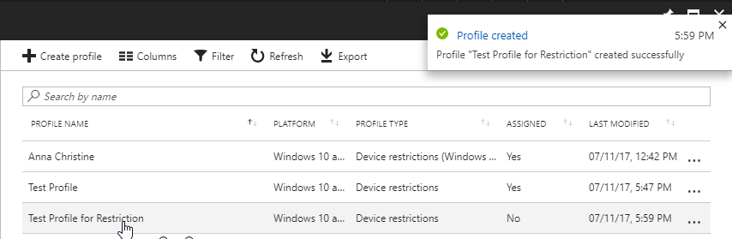

1. You can go ahead and assign this profile to groups. By clicking on **Manage** > **Assignments** in the created profile blade.

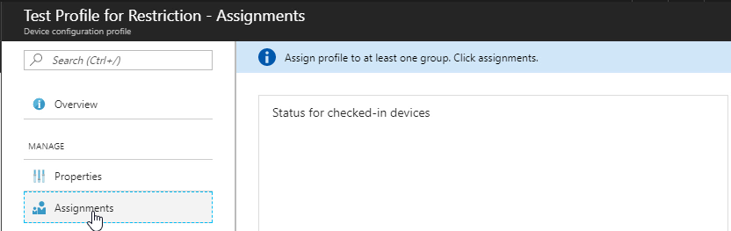

1. On the next blade, choose either **Include** (to include groups) or **Exclude** (to exclude).
2. And, select a group to include or exclude as per your selection. You can hold down the CTRL key to select multiple groups. Then click **Select**.

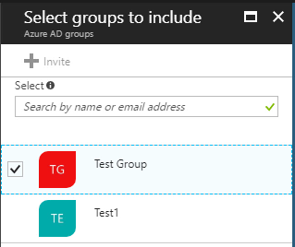

1. Then click **Save**, in the assignments blade. Also you will get **assignments saved successfully** notification at the top right corner.

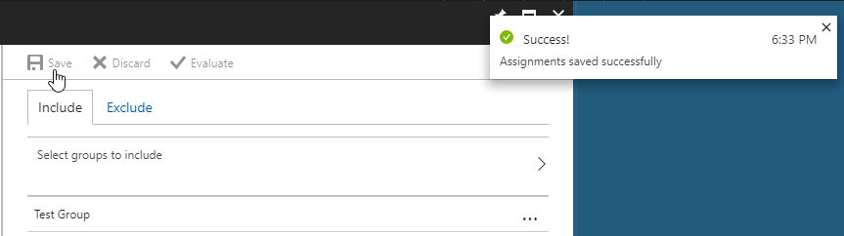

1. So, in this way you can create device restriction profile in Microsoft Intune.